Sr Celine Marie’s Solemn Profession of Vows

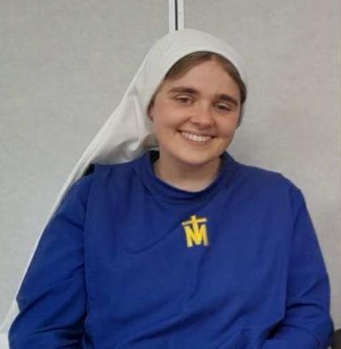

The Doodeman family invites you to join them in praying two novenas leading up to the vows on the 27th November, the feast of Our Lady of the Miraculous Medal.

The 1st Novena is to St Therese, her patron. This will start on Sunday 9th November.
https://www.ewtn.com/catholicism/library/novena-to-st-therese-of-the-child-jesus-11885

The 2nd Novena is to Our Lady of the Miraculous Medal beginning on Tuesday 18th November.
https://www.ewtn.com/catholicism/library/miraculous-medal-novena-9129

Parishioners are invited to add their names to a card from the parish to mark this occasion. Names can be left with Heather at the Parish office or alternatively by calling or texting Lisa on 0472 719 581.

